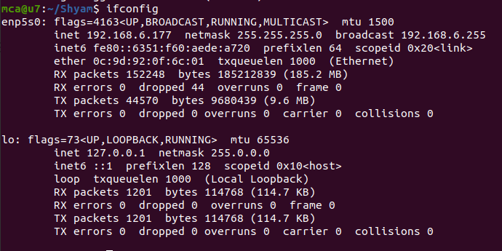

Mtu - maximum transfer unit

Ip address line 3

Mac address line 4

* Ifconfig is used to configure the kernel-resident network interfaces.It is used at boot time to set up interfaces as necessary. After that, it is usually only needed when debugging or when system tuning is needed.

* The ifdown command disables a network interface, placing it in a state where it cannot transmit or receive data.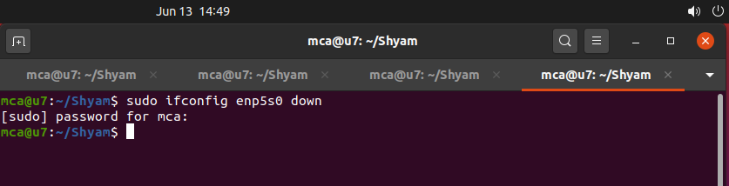
* ifup activates a network interface, making it available to transmit and receive data.

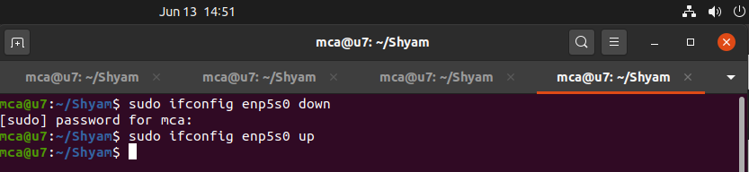

* PING (Packet Internet Groper) command is used to check the network connectivity between host and server/host. It is used to detect devices on a network and for troubleshooting. Fast ping low latency means faster connection.

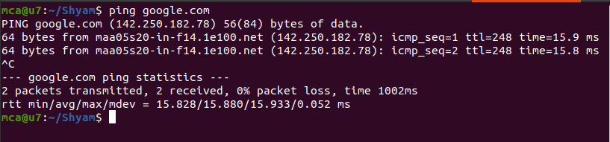

$ ping -c 3 google.com

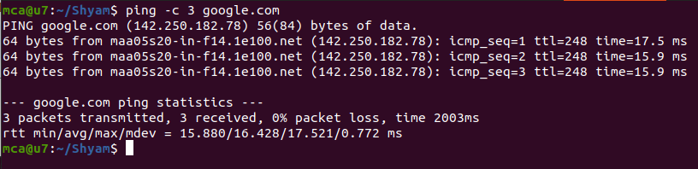

$ ping (ipaddress)

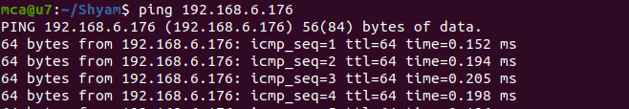

$ traceroute google.com

It is used to identify the route taken by the packets to reach the destination.

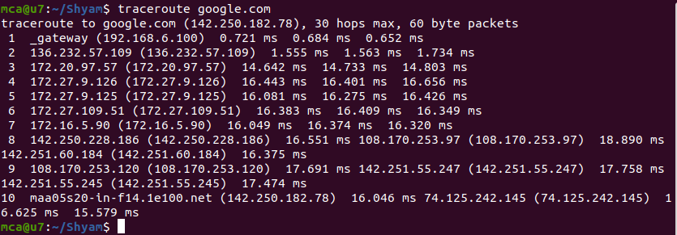

$ whois

The whois command displays all information about a specific domain.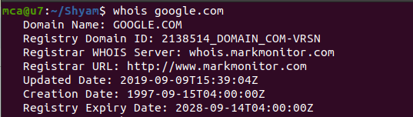

$ nslookup

The nslookup command is a tool used to query Domain Name System (DNS) servers and retrieve information about a specific domain or IP address.

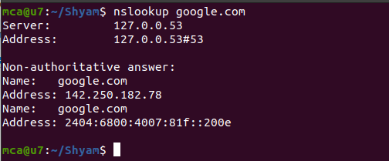

$wget

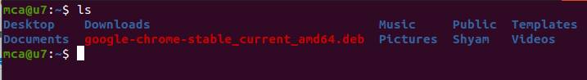

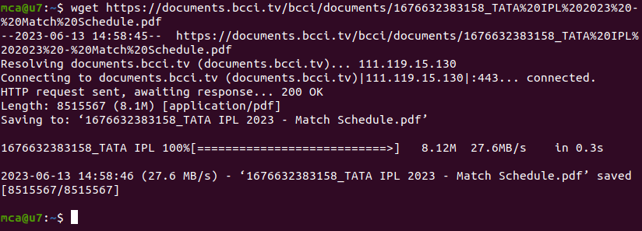

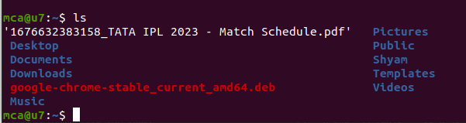

$ sudo tcpdump

It is used to capture the packets of current network interface.

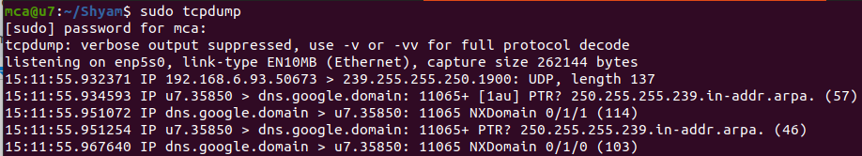

$ sudo tcpdump -D

It is used to capture packets from available interfaces.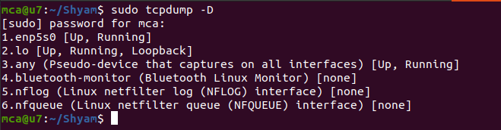

$ sudo tcpdump -i (interface)

It is used to capture packets from a particular interface.

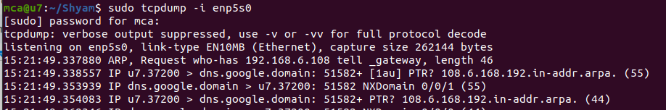

$ sudo tcpdump -c n -i enp5s0

It is used to capture n packets from a particular interface.

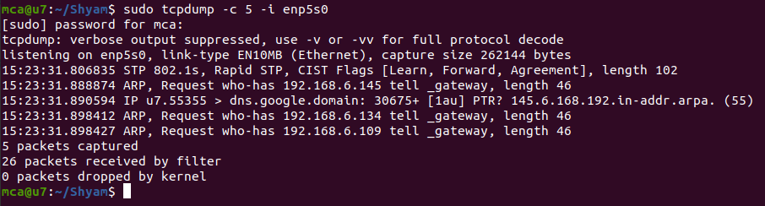

$ sudo tcpdump -A -i interface

To display in ASCII format.

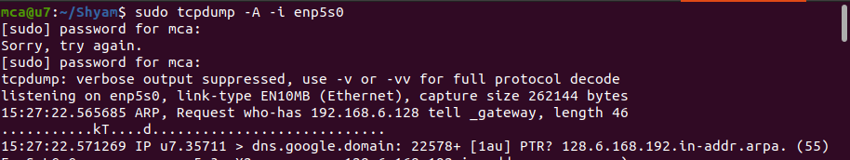

$ sudo tcpdump -XX -i interface

To display in Hexadecimal format

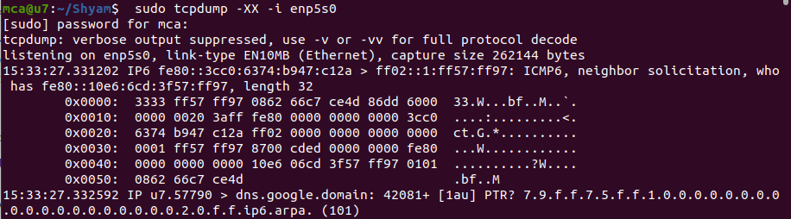

$ sudo tcpdump -w ab.pcap -i interface

